|  |
| --- |
| Circle Language Spec |

## Pointers

### Brainstorm

The 'pointer-to-pointer' issues seem to be a bit spread over the chapters. When a chapter is explained, afterwards it seems to evaluate how things would look in pointer-to-pointer situations. The idea is that all of those pointer-to-pointer situations might be put here in this chapter instead. Topics like objects, classes, interfaces, assignment, seem to able to live without thinking about pointer situations, and pointers just seems a single problem area that might be desirable to cover separately.

It might be worth highlighting there may be different interpretations of pointers, lines and their direction. They seem to be non-competing. Here is an attempt to summarize some of them:

* Interpretation 1:
  + Line direction would not matter, only aspect correspondence would matter.
* Interpretation 2:
  + Direction tends to point outwards, if inward, this would be denoted with an access symbol.
  + The notational choice would be arbitrary and carry no special meaning.
* Interpretation 3:
  + Directions tend to point outwards, if inward, this would be denoted with an access symbol, like previously.
  + Inward directions would actually be more 'active' redirections/accesses: Pointer-to-pointer redirections, getter accesses, calls to procedures returning an object, etc.
  + Outward directions, would be more passive. They might represent 'simple' pointers, not represent getter calls or anything, more like indications of aspect correspondence.
* Interpretation 4:
  + All symbols would be pointers, kind of like in some languages objects might be accessed through singly-redirected object references (C# assumably).
* Interpretation 5:
  + There would be one symbol in the diagram, that represents the actual object, not a pointer to it.
  + It might be found by first following all outward redirections, then all the inward ones.
  + Where it ends, might be the 'target' symbol: The actual target of the redirections that might be said to be represent the actual object, rather than just a reference to it.

### Brainstorm Ref-Ness

Another topic that might be covered, is a comparison with other languages (even though one of the strategic items is to not try and compare so much in this text, with the idea that 'where would it end?') An exception to the rule could be made here to add a comparison to other language's ref-ness, because Circle seems to be 'make a mockery' of the concept ref-ness in a way. C# or C++ seem to be specific about ref-ness. (C++ might make you specify asterisks ** to indicate how many redirections a pointer variable makes; C# and .NET seem to assign intrisic importance to defining parameters as ref or out and what other 'ref-nesses' have you? Anyway, they seem quite specific.) Circle however, seems to make a 'mockery' out of this, because all you need to do is add a line and the ref-ness changes. And the ref-ness does not seem to be specified near the start of the pointer redirection, but you might arbitrarily let redirections be added by the thing you are pointing to. 'mockery' is a meant a bit humoristically here, of course. It is just a notation. If the diagrams might represent something from C#, rules are probably just bound by what you can do in C#. You simply might not be able to add more redirections, or might not validly specify something with not enough redirection. Getter accesses in C# might actually be C#'s own embodiment of indeterminate ref-ness. Or depending how lightly you might want to apply the diagram language, it might not really matter that much, this ref-ness issue and these diagrams. But what might become a splinter in your brain, is that Circle does not seem to have a notation (yet) to specify fixed ref-ness. And what might rub some against the fur, is that Circle seems to like indeterminate ref-ness while some might hold determinate ref-ness in great value perhaps. The notion that there are these ideas about that, might justify thinking about it and perhaps describing a way to elegantly solve it or perhaps find a way to live with things the way they are.

### Target Objects

An object reference can* point to another object reference, which* points to another object reference and so on. The* first* object found in this redirection, that does not refer to another object again*, is called the* *target object*. Even* though* any of the* object *references* can be used like it is the* object itself, the* *target object* is considered the* real object and not just* a reference to it.

The* term target object is also used to denote the* direct* reference target, not necessarily the* final target. What kind of target is denoted, will be clear from the* context.

#### Compared to C++

In C++ you* had to specify* in advance* the* number of pointer redirections of a variable. In the* new computer language a symbol can follow any* amount of indirections, from zero* to infinity. You* do not specify* the* amount of redirections in advance*. You* can just add a redirection by turning* the* target object into a pointer.

#### In a Diagram

The* target object is the* last* point in a string of object reference redirections.

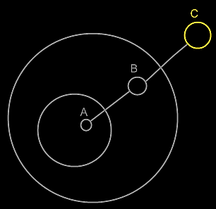

Symbol **A** is an object reference to symbol **B**. Symbol **B** is an object reference to symbol **C**. Symbol **C** is the* target object of both* symbols **A** and **B**.

The* idea of target objects is also* a way to make a single* symbol in the* diagram represent the* actual object, whereas the* others are just* seen as references to the* object: to have the* actual* object only* represented by a single* symbol in the* diagram.

### Target Classes

#### Concept

A target class is found by following the redirections, that lead to a symbol’s class.

Do not follow more than one class redirection, because if a class points out a class again, then the second class is *another* class object, that the first class is just *based* on. If the class is an object reference itself, you have to follow all object redirections to find the target class object. Then you have found the target class. That’s where redirection following ends. If the class object has a class itself, you might be tempted to follow the class object’s class redirections as well, to find the final target class, but you should not do that. The first class redirection indicates the class. If that class object has a class itself, then the class object is only based on another class, but it *is* a class on its own. An object redirection is just a much tighter bond like that, than a class redirection.

#### Diagram Notation

The concept of target classes is explained in the article *Target Classes*. This article only explains their expression in a diagram.

The target class is found by following the redirections, that lead to a symbol’s class.

When you want to find the class of an object, and the object is actually an object reference, you first need to follow all object reference redirections, to find the target object. When you found the target object, you can find the target class, by following one class redirection.

So to find the target class, you first follow *all* the object redirections, then *one* class redirections, then *all* the object redirections and there it ends.

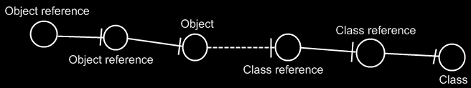

If the class has a class as well, this does not redirect the original object’s class, because the second class is *another* class object, that the first class is just *based* on. An object redirection is just a much tighter bond, than a class redirection.

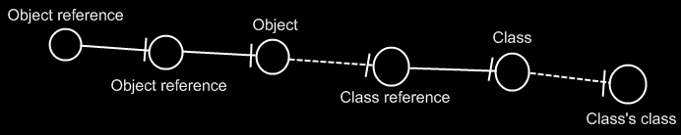

The target class of the first object reference is the symbol Class, not the symbol Class’s class. The same counts for the diagram below.

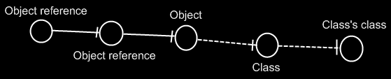

If you wonder what could be that different between Class and Class’s class: they could differ in default values. The main point is: finding the target class is about finding the class object.

### Multiple Class Redirections

Below is an example, with classes getting further redirected.

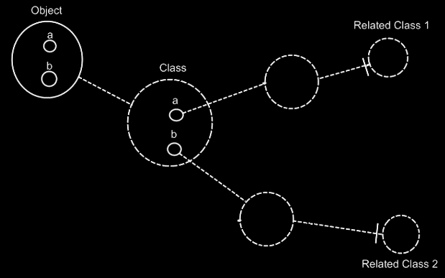

### Relation to a Pointer

#### Concept

As covered by the* article *Related Classes*, you* can* also establish a unidirectional relation with a *pointer* to another class. This is not* so common, but* it is possible all the* same. This is mostly applied, to allow a class to make a sub-object’s class *adjustable*. It is important to consider, that everything inside a pointer is really part of the* *target class*, but* a pointer itself is usable individually, independent from the* target class. This is well visualized in the* article *Relation to a Pointer in a Diagram.* To make a relation to a pointer bidirectional, you* have to give the* target class a relation back to the* first class. The* first class relates to the* pointer, but* the* target class relates back to the* first class. This automatically gives the* pointer a relation back to the* first class. This creates a bidirectional relation between the* first class and the* pointer to a class, but* only a unidirectional backwards relation between the* target class and the* first class. This is because* the* first class does not* directly refer to the* target class, but* the* target class does directly refer back to it. You* should see it in a diagram. That will make it much clearer.

#### Diagram Notation

You* can* also establish a unidirectional relation with a *pointer* to another class. This is not* so common, but* it is possible all the* same.

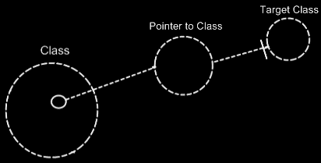

This is mostly applied, to allow a class to make a sub-object’s class *adjustable*.

It is important to consider, that everything inside a pointer is really part of the* *target class*, but* a pointer itself is usable individually, independent from the* target class.

To make a relation to a pointer bidirectional, you* have to give the* target class a relation back to the* first class.

The* relation back can* be displayed in both symbols, that represent the* target class:

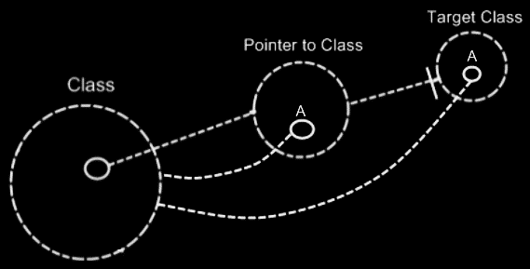

The* two unidirectional relations between **Class** and **Pointer to Class** melt together to a single bidirectional relation. But* the* unidirectional relation from the* **Target Class** to the* **Class** stays unidirectional, because* **Class** does not* directly relate to **Target Class**:

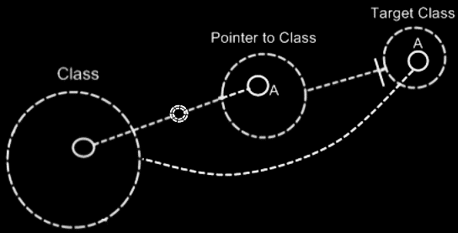

The* notation for a bidirectional relation was covered by the* article *Relations in a Diagram*.

So only **Class** and **Pointer to Class** get a bidirectional relation to eachother.

**Target Class** keeps a unidirectional relation to **Class**. Funny enough, that unidirectional relation is part of the* bidirectional relation between **Class** and **Pointer to Class**. The* bidirectional relation actually consists of:

- **Class** relates to **Pointer to Class**

- **Target Class** relates back to **Class**

The* connection between **Target Class** and **Class** is already implied by the* connection between **Pointer to Class** and **Class**. You*’re allowed to leave out of the* diagram then*:

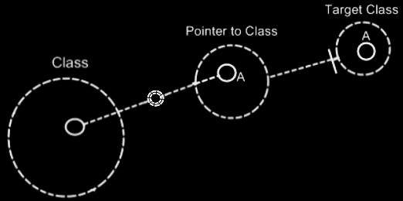

**Target Class** and **Class** are already implicitly related to eachother through the* pointer to the* target class.

In all the* diagrams above, that display the* backward relation, the* sub-symbols of **Pointer to Class** and **Target Class** were given a name: **A**. This was done, because* there was no line in the* diagram to indicate that they were the* same sub-object. Officially, when* symbols share an aspect, in that they are equal in object, class, interface or definition, they should be tied together with a line. Officially an object line should have been connecting both symbols of **A**:

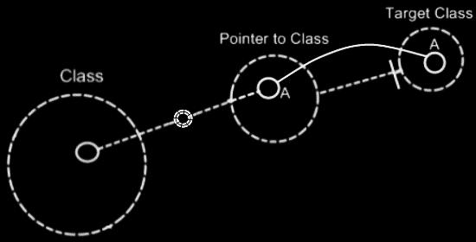

But* similarity in aspect can* also be implied by a *name* and the* *connection between parents*. This kind of implicit connection is explained in the* article *Automatic Containment*.

The* only point to implicit connection through parent is to make the* diagram clearer.

## Loose Ideas

### Loose Ideas about Target Objects

Objects,

Target,

2008-07-26

I need to rename the* term Target Object, Target Class and Target Interface to Final Object Target, Final Class Target and Final Interface Target, because I’m not targeting an object, class or interface, but I’m targeting an object reference representing an object, class or interface.

Also the* term object target is the* same as direct object target. That also counts for classes and interfaces.

The* term Target Object, Target Class and Target Interface have less of a use now. But the* way they are used now is misleading.

JJ

(Out of the original Symbol documentation)

#### Object Trace

< 2008-10-06 Probably not right anymore. >

To find the* target object, you*’d expect to only follow object lines. However, there’s a pitfall: a situation that does not occur a lot, though.

If a type line points to a symbol with an object line, the* type is a single object.

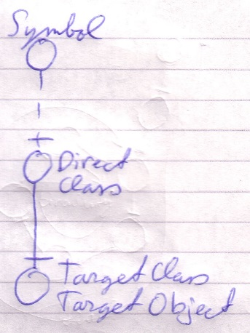

Each instance of the* type is actually the* same object.

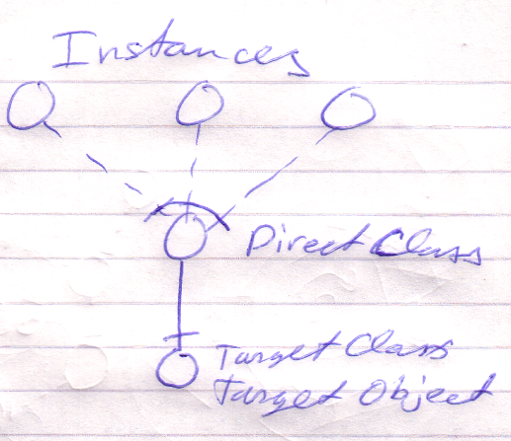

Therefore, a type line can redirect the* object of the* symbol. Therefore, type lines need to be followed to find the* object.

The* last symbol pointed to by an object line is the* object.

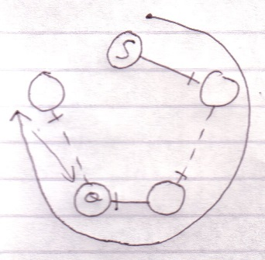

This kind of redirectioning is called an *object trace*.

Delegating the* object aspect is the* main type of object redirection.

#### Idea

In C++ bepaal je de redirection diepte vooraf:

Int ***TripleRedirected

In Symbol kan je de redirection diepte achteraf bepalen

Als je in C++ een object referenties toewijst aan een object referentie, dan wijs je niet naar de object referentie, maar naar het target object. Symbol heeft meer structurering hier.

#### Multiple Redirection and Final Targets

If an object symbol has an object line to a symbol that again has an object line, there is redirected until a symbol without an object line is encountered: the* *target object*.

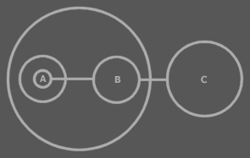

C is the* target object of A and B.

The* target object symbol is regarded to represent the* object for real. The* other symbols are references to the* object.

The* same way there are symbols serving as a *target type* or a *target interface*. Also a procedure has an interface target. A procedure also has a call target and reference target. In both those cases reference lines are followed.

### Loose Ideas about Target Classes

(Out of the original Symbol documentation)

#### Tracing Object Aspects

Formerly I’ve said that when you encountered a symbol that doesn’t have a type line, then it is the target type. But in *Object Basics* I said that when a symbol doesn’t have a type line, the object line functions as the type line. Therefore, if a symbol has no type line, the type can still be redirected by an object line.

Finding the aspects of a symbol, such as target object or target type, is called a *trace*.

##### Type Trace

You’ll use type and object lines to trace the type. Follow the type line if it exists, else follow the object line. When you run into a symbol with no type or object line, then that’s the type.

When there is no type line, the object determines the type.

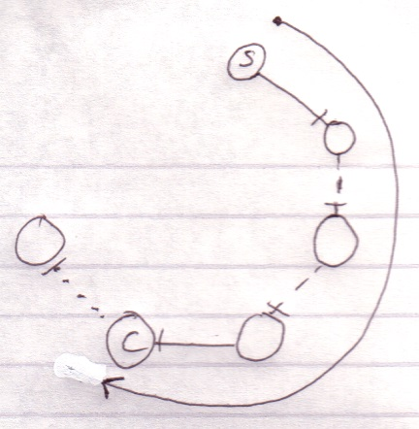

Interface lines are not followed. Note that the target type doesn’t have to be pointed to by a type line.

##### Object-Type Trace

The last symbol in the object trace altogether:

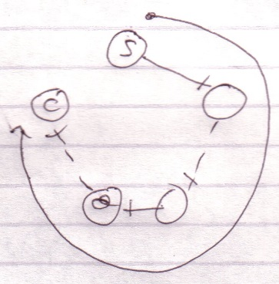

is the target type.

Therefore, *object* trace can also point out to the target *type*. The difference with a *type trace* is that a type trace prefers to follow type lines over object lines and an object trace prefers to follow object lines over type lines. However, both redirections lead to the exact same symbol.

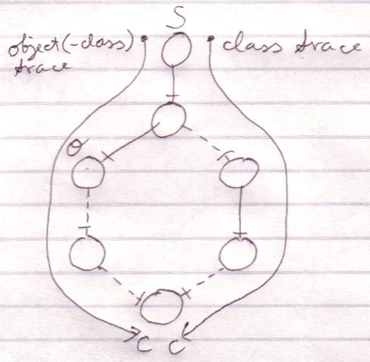

It happens a lot that you want to find out the object and the type in one blow. So you may as well use the redirection of the object trace for the benefit of finding the object and type in one blow. The trace is then called a *object-type trace*.

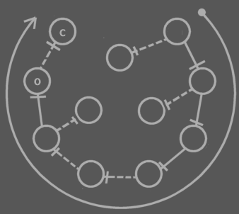

The last symbol in the redirection altogether is the target type (**C**). The last symbol pointed to by an object line is the object (**O**). Note that the target type may be pointed out by an object line.



When you only want to find out the type, it is better to use a type trace than it is to use an object-type trace. Type trace prefers type lines over object lines. Type lines generally follow less redirections before reaching the target type than object lines do.

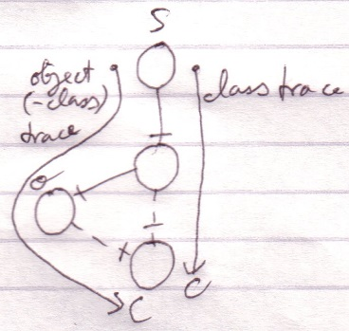

##### Tracing is Not Always Hard

If an object symbol has no object line or type line, then finding the target object and type is much simpler, because no redirectioning at all takes place. The symbol is its own object and type.



Traces usually don’t require as many steps as in the examples above.

Targets,

2010-05

> I do not know how it works yet. Now my mind says: follow all redirections, including multiple interface redirections… but in the Target Class story I stopped doing that. Maybe it is just what you want the term Target Interface to define. Maybe it is not even important. I don’t know.

> Perhaps there should be a distinction between interface definition and target interface. I do feel that both the ‘follow only one class or interface step’ version is a concept to be aware of, but the target interface concept would actually be following all redirections to find the object that actually determines the publics.

> Yes. What is now called Target Interface should probably be called the *Interface Object* and the *Target Interface* is the object after following all types of redirections in any order.

JJ

### Other Loose Ideas

Pointer to class of,

2008-08-17

Consider the notation of pointing to the class of an object reference, used in the article Class Referrers in a Diagram.

I need a notation for explicitly referring to a pointer or to the class of an object or to the class of an object reference.

Do consider that the target object in a diagram really needs to represents the object. You should not think of it as an object reference, because that will make it harder to see through the system.

> 2020-06-13: Might it be an idea to consult the system interface to point to the class of an object symbol? So the system interface might show the class and that bit of the system interface might be shown, and an object reference would point to the class indication in the system interface? Something like that.

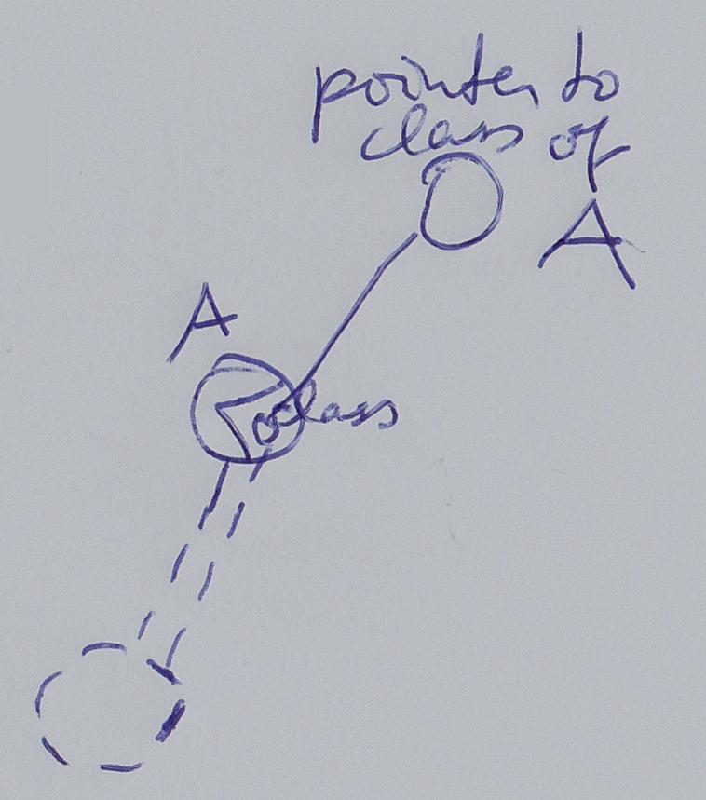

JJ

### Loose Ideas about Relation to a Pointer

Relations,

Relations to Pointers,

2008-09-25

Pointers (references to related objects)

A relation between a *pointer to an object* and a *command*. The* pointer is a totally different entity, than the* object itself.

> 2008-10-01 I’d think, that this will add related objects to the* system interface, so related objects to a related item system object, instead of related objects to the* target object of the* related item system object.  
This is a relations issue: relations to pointers in particuler.

I will need to look at *System Objects* to see what a pointer actually was: it was a relation to a related item, instead of a relation to an object independent of any other container.

JJ